RAINBOW
NURSERY

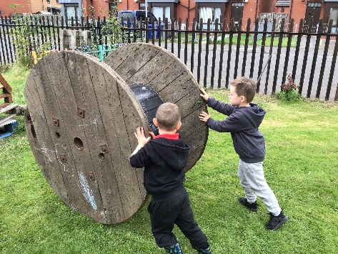
APPLICATION
FORM

CONTACT –

ALAN CUNNINGHAM - NURSERY MANAGER

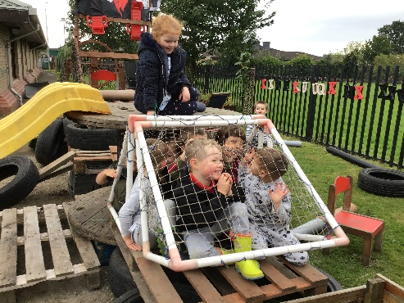

Rainbow Nursery
Fullerton Street
Paisley
PA3 2NN
Phone: 0141 840 4080
Email: Rainbow@childcarefirst.com

Date

Full Name of Child

Gender Female: Male:

Date of Birth Day Month Year

Due date (expectant mums) Day Month Year

Age at Date of Enrolment Years Months

Address

Post Code

Telephone No

Email address

Days Required Mon Tues Wed Thurs Fri

Times Required Mon Tues Wed Thurs Fri

Names & Ages of other children in family

1. Name Age

2. Name Age

3. Name Age

4. Name Age

Do any of your children attend another nursery (please tick)

Yes No

Name of Nursery

1.

2.

3.

4.

Parent /Guardian 1 Parent /Guardian 2

Name

Address

Postcode

Home Tel No

Occupation

Hours per week

Start Date

Name & Address of Employer/Training Officer/Education Establishment

Work/Training
Tel No

Rainbow Nursery has been accepted onto Renfrewshire Council’s framework to provide Pre School Education and can provide 1140 Pre School Funding for children aged 3-5years and eligible 2-year olds this also includes free lunch entitlement.

Personal data will be processed in accordance with our privacy policy which is available at http://www.childcarefirst.com/CCPrivacyNotice2018.pdf

Additional information to support your application

Signature of parent or Guardian

ADVICE AND SUPPORT

Do you know that you can get help with childcare costs from the Inland Revenue?

Have you claimed your Childcare Credits?

Are you claiming all the benefits that you are entitled to?

If you are on a low income you may be able to get assistance from Equal Access to
Employment.

Here are some useful contact details for services that can give you advice on your
Entitlements and how to claim them.

Targeted Advice Project / Advice Works
9 Collier Street
Johnstone
PA5 8AR
01505 382 328

Inland Revenue
Working Tax & Childcare Tax Helpline: 0845 300 3900
Local Offices: Gilmour Street, Paisley
0845 302 1448
0141 840 5600

Citizens Advice Bureau
Sherwood House
7 Glasgow Road
Paisley
0141 889 2121

Rainbow Nursery
Funded by

